

School of Computing, Creative Technology, and Engineering

**Module: Advance Web engineering**

**Level 6: Term 1**

**Assignment Title: Component - 2**

**Student Name: Jiya Yadav**

**Student ID: LEEDSBECKETT\c7298000**

Table of Contents

Login Credentials 4

Customer: jack@gmail.com password: jiya@123 4

Admin: jiyayadav102@gmail.com password:12345@jiya 4

Super Admin : gcgintl.00@gmail.com password: gcg@12345 4

YouTube video link: 4

GitHub link (local): 4

GitHub link (Leeds Beckett): 4

Home page 5

About Us Page 7

Product and Pricing page 7

In the product pricing page users can sort product by price and also my categories. 7

Contact Us Page 8

Testimonials page 9

Login page 9

Fields should be empty and Gmail must have @ and login after the right credentials: 10

Register Page 11

For register Gmail must be unique and password should match and there must be 8 characters 11

Product Details page 12

This is the product details page is only accessed if the user is logged in. 12

Payment gateway 13

Payment will be done by PayPal. 13

Forget Password 14

Manage Products 17

This page accessed by the Admins and Super Admins. 17

Profile Edit page 17

Product edit page 18

Admin and super admins can update the details of the products. 18

Product deletes 19

Admin and super admins can delete the details of the products. 19

Product creates 19

Admin and super admins can create the products. 19

Manage Users 20

Only super admins can manage the user. 20

User update 20

User delete 21

Error page 21

Codes 22

Git hub: 27

Local: 27

Leeds Beckett: 27

# Login Credentials

## Customer: [jack@gmail.com](mailto:jack@gmail.com) password: jiya@123

## Admin: [jiyayadav102@gmail.com](mailto:jiyayadav102@gmail.com) password:12345@jiya

## Super Admin : [gcgintl.00@gmail.com](mailto:gcgintl.00@gmail.com) password: gcg@12345

ECOCRAFT is an e-commerce website which has eco-friendly products. There are three users in my project as:

Customers: Can access products details page and can buy products only after login

Admin: Can access product manage page

Super Admin: Can access product manage page as well as the users manage page

# YouTube video link:

https://www.youtube.com/watch?v=045bLMzVAms

# GitHub link (local):

<https://github.com/tbc-bsc-l6/component-2-JIYA-TBC>

No of commits: 29

# GitHub link (Leeds Beckett):

<https://github.com/comp-bkt/component-2-JIYA-TBC>

No of commits: 29

# Home page

This is the home page:

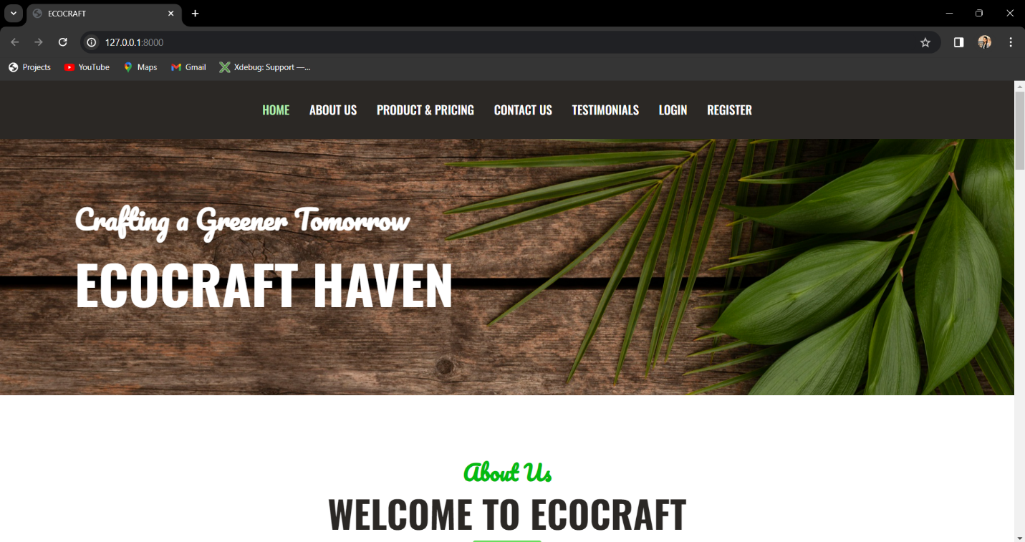

This is the footer:

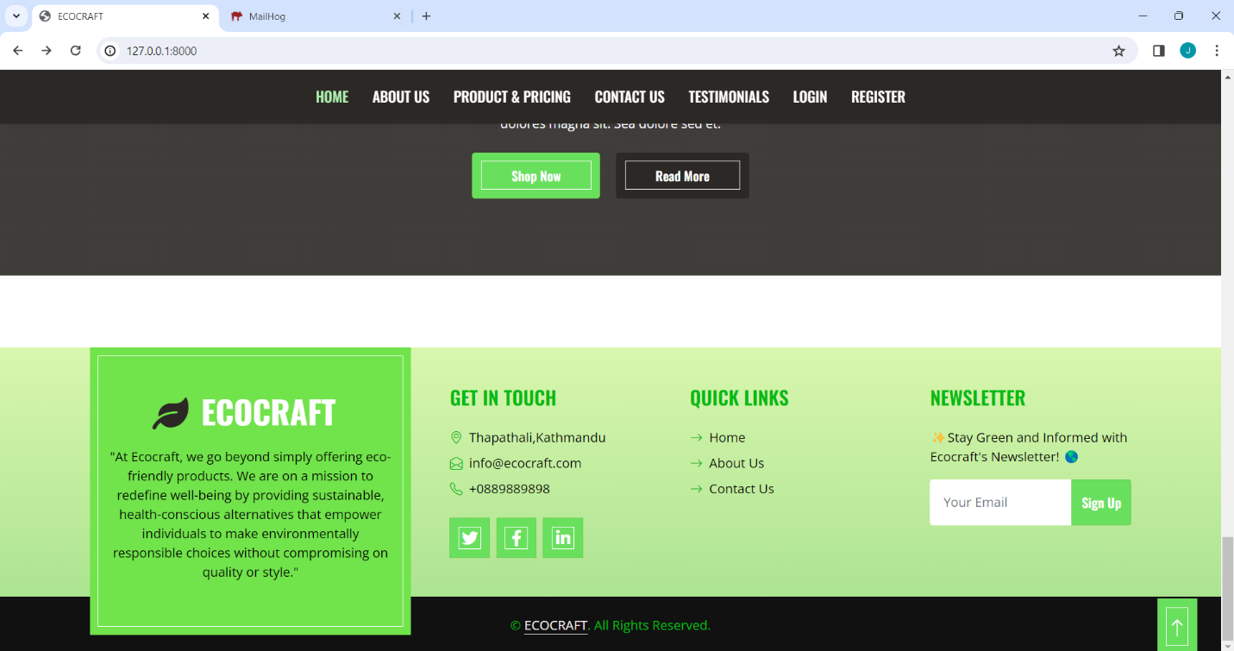

# About Us Page

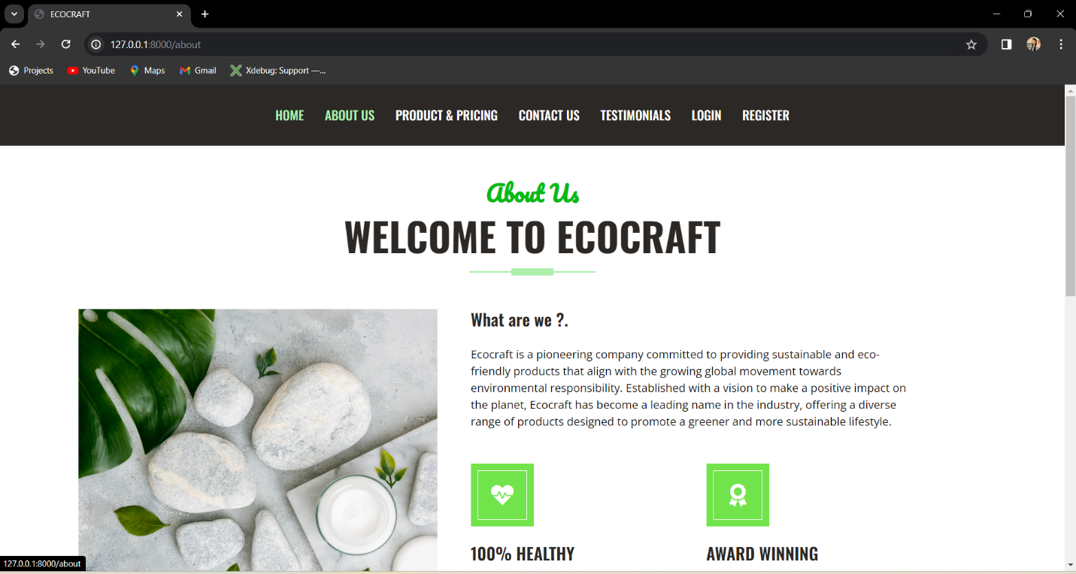

# Product and Pricing page

In the product pricing page users can sort product by price and also my categories. Similarly, they can search products.

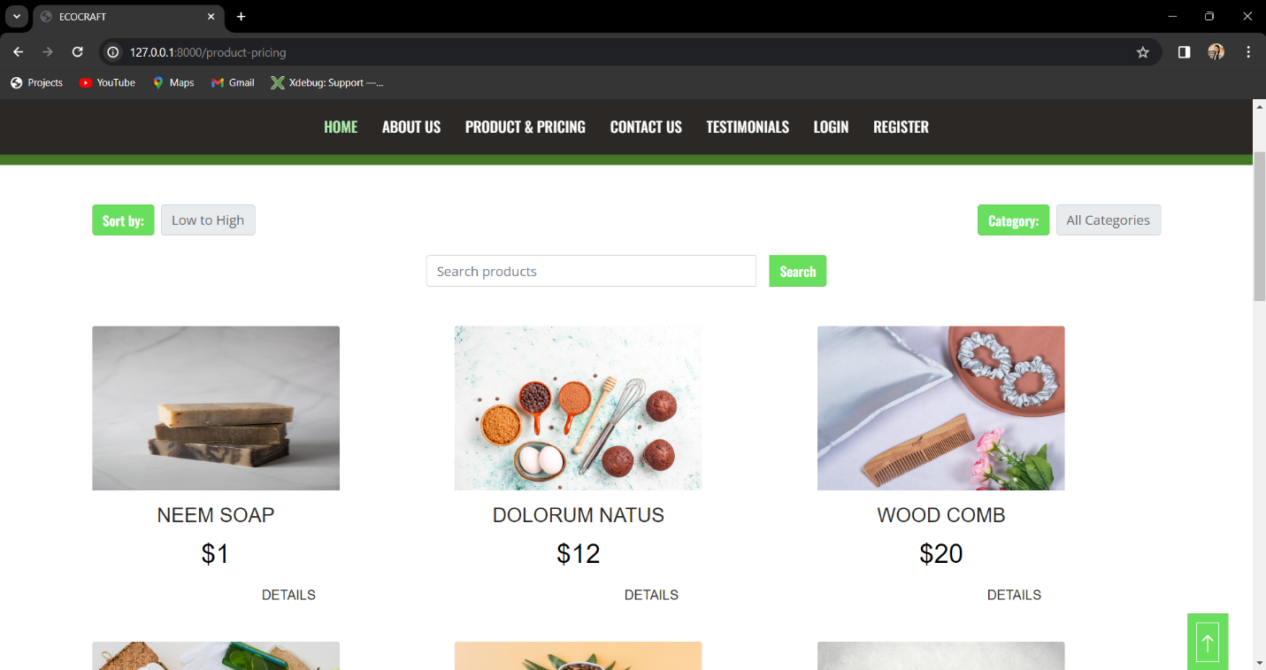

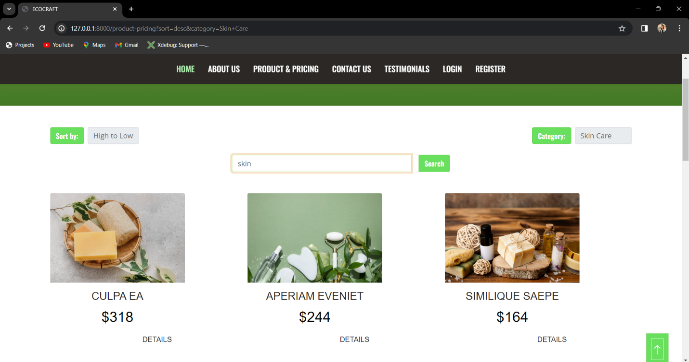

# Contact Us Page

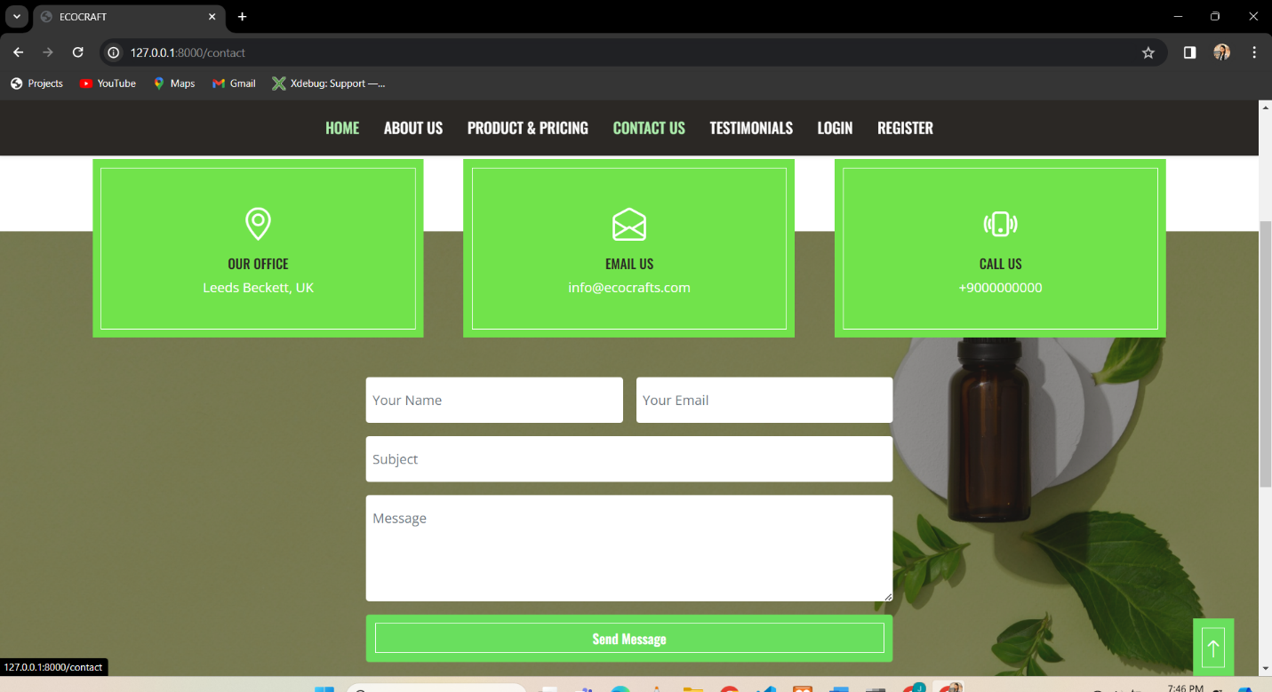

# Testimonials page

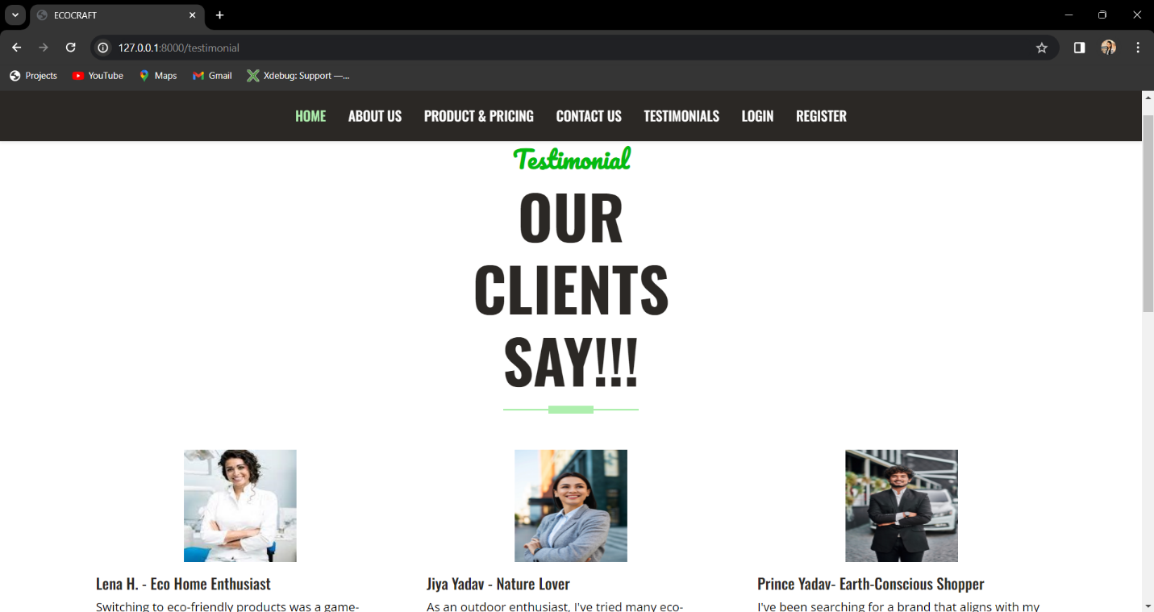

# Login page

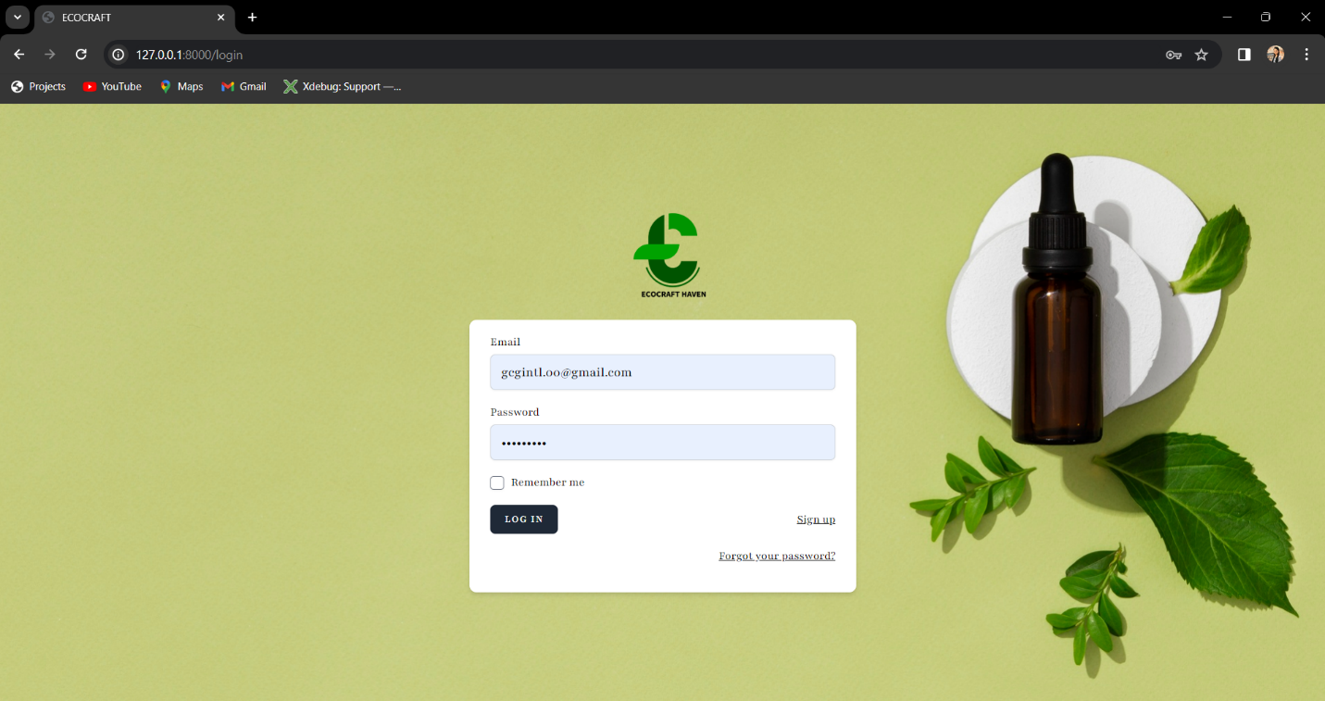

Fields should be empty and Gmail must have @ and login after the right credentials: 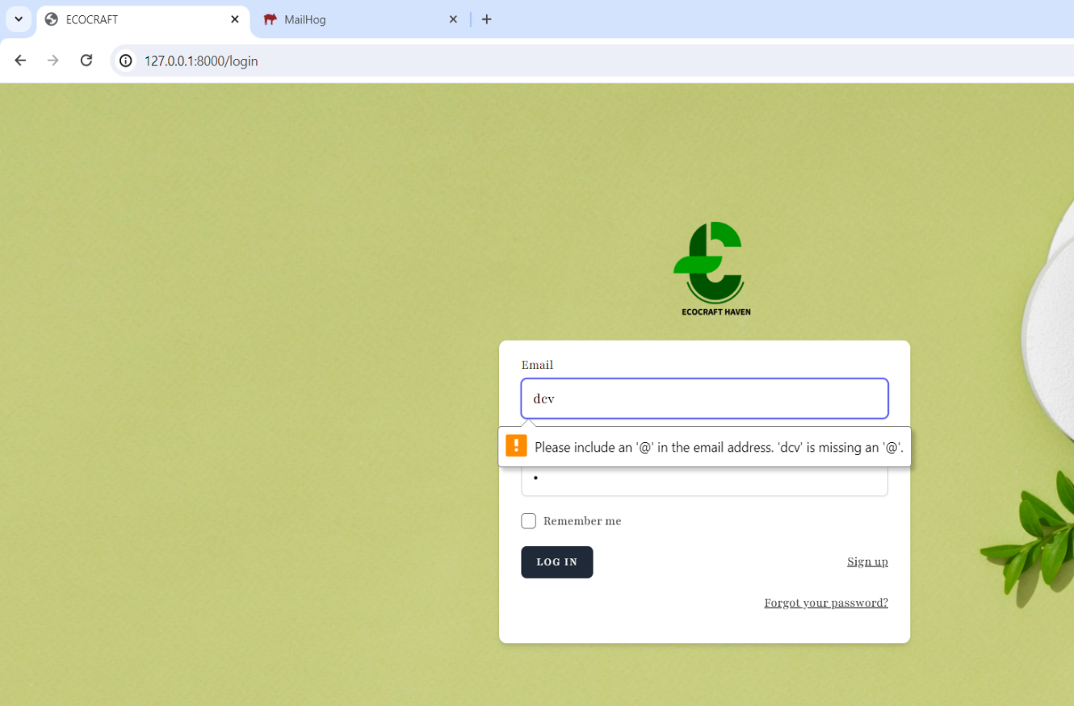

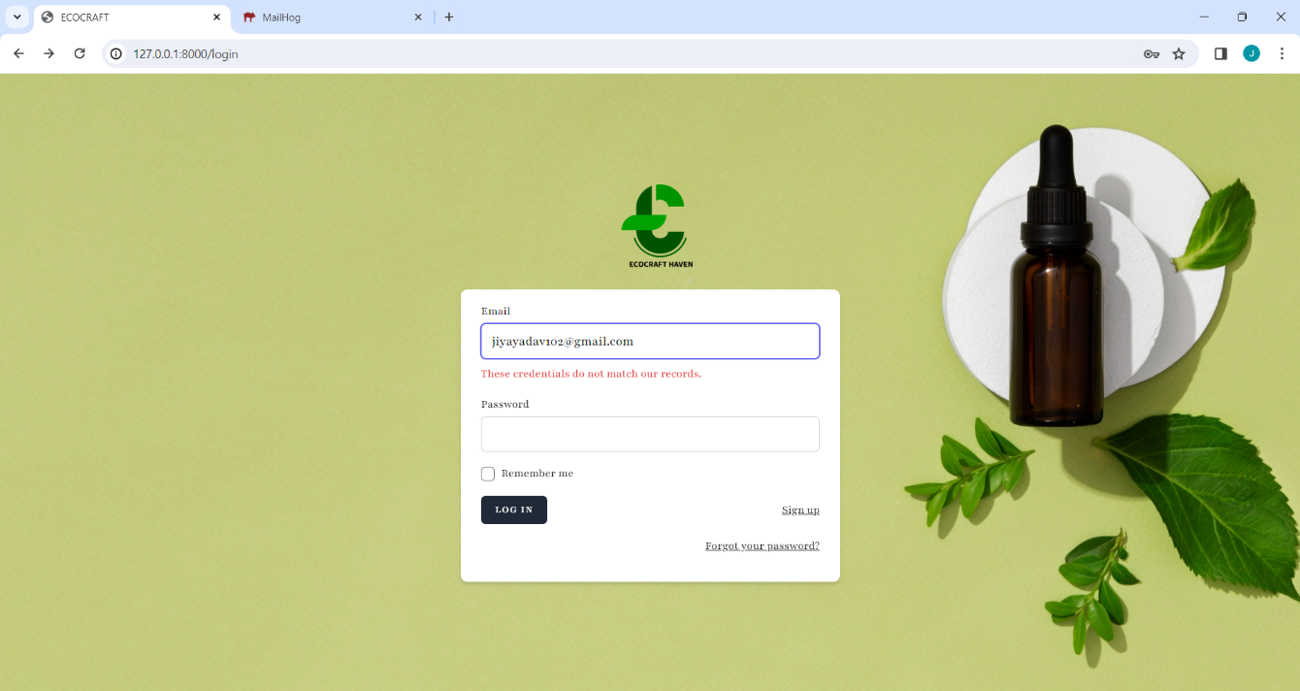

# Register Page

## For register Gmail must be unique and password should match and there must be 8 characters

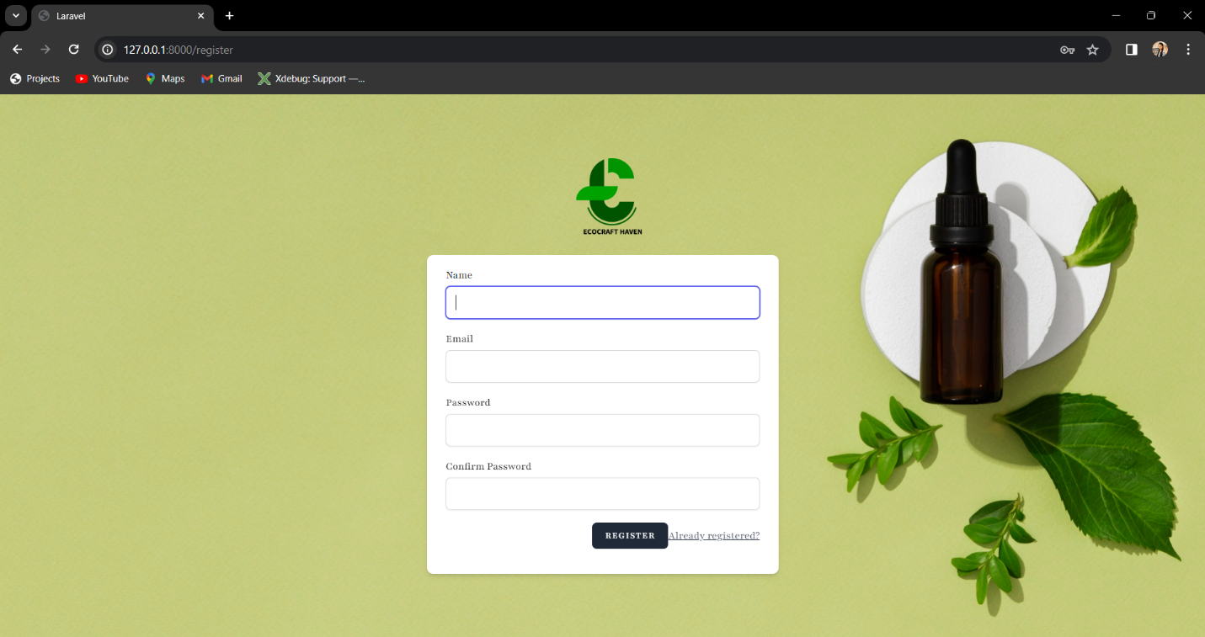

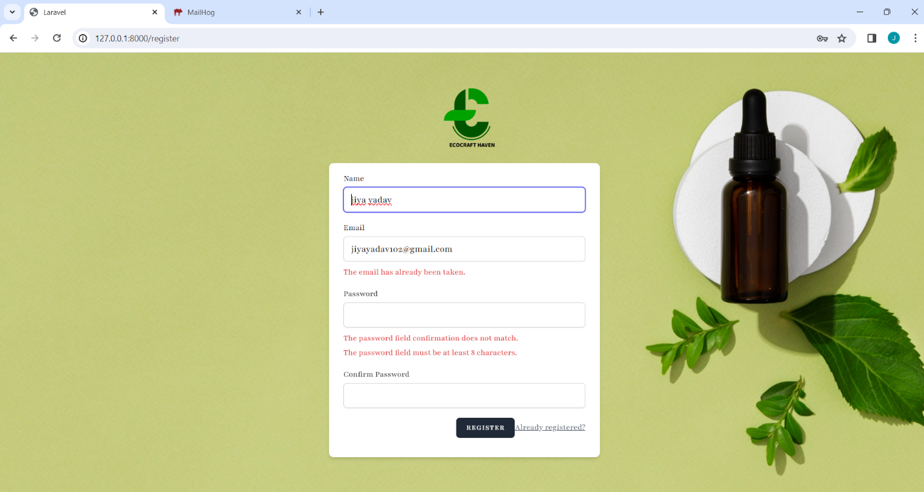

# Product Details page

## This is the product details page is only accessed if the user is logged in.

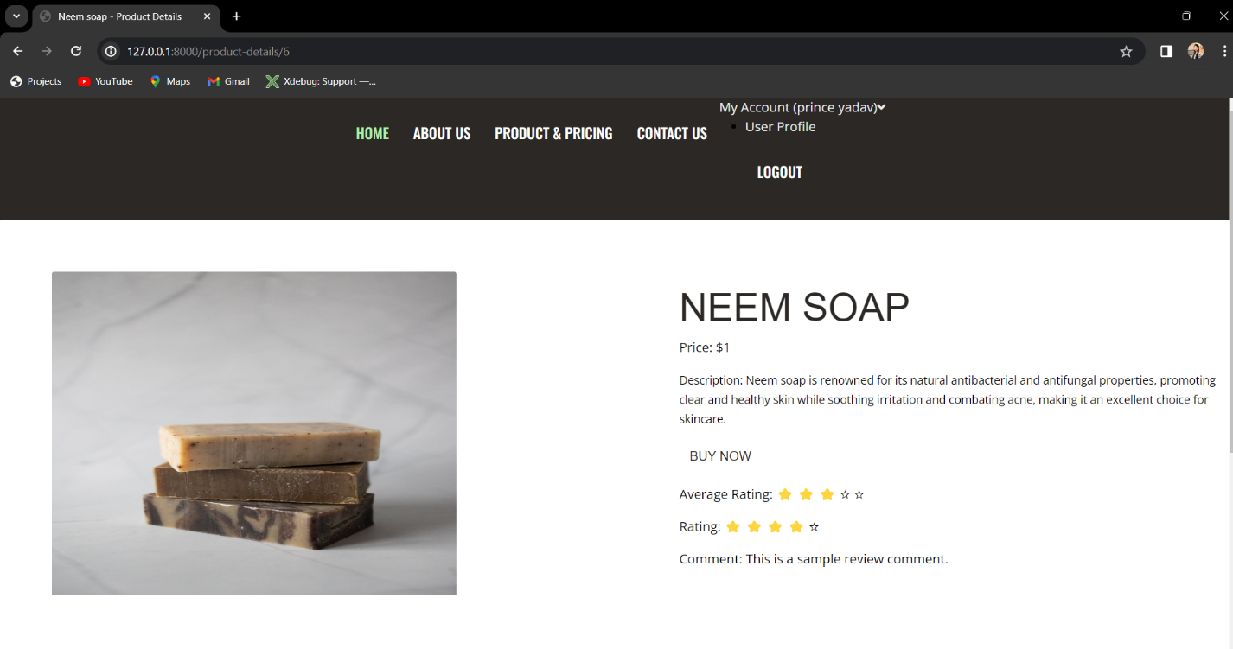

# Payment gateway

## Payment will be done by PayPal.

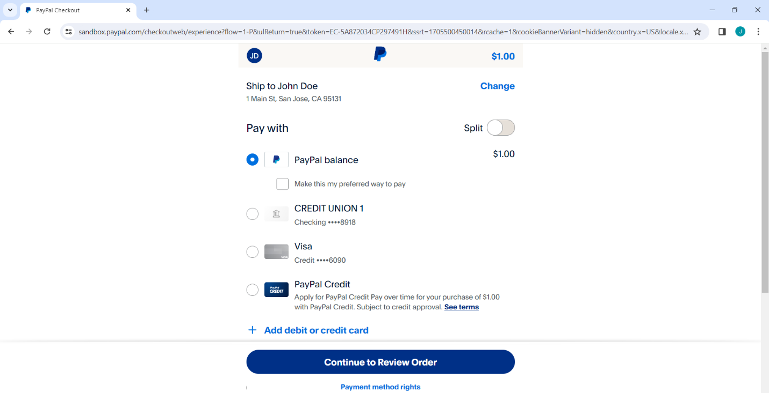

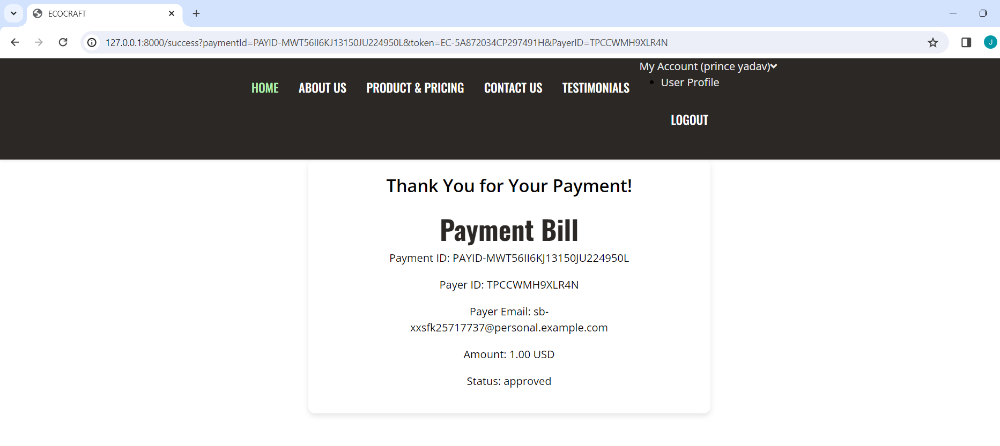

# Forget Password

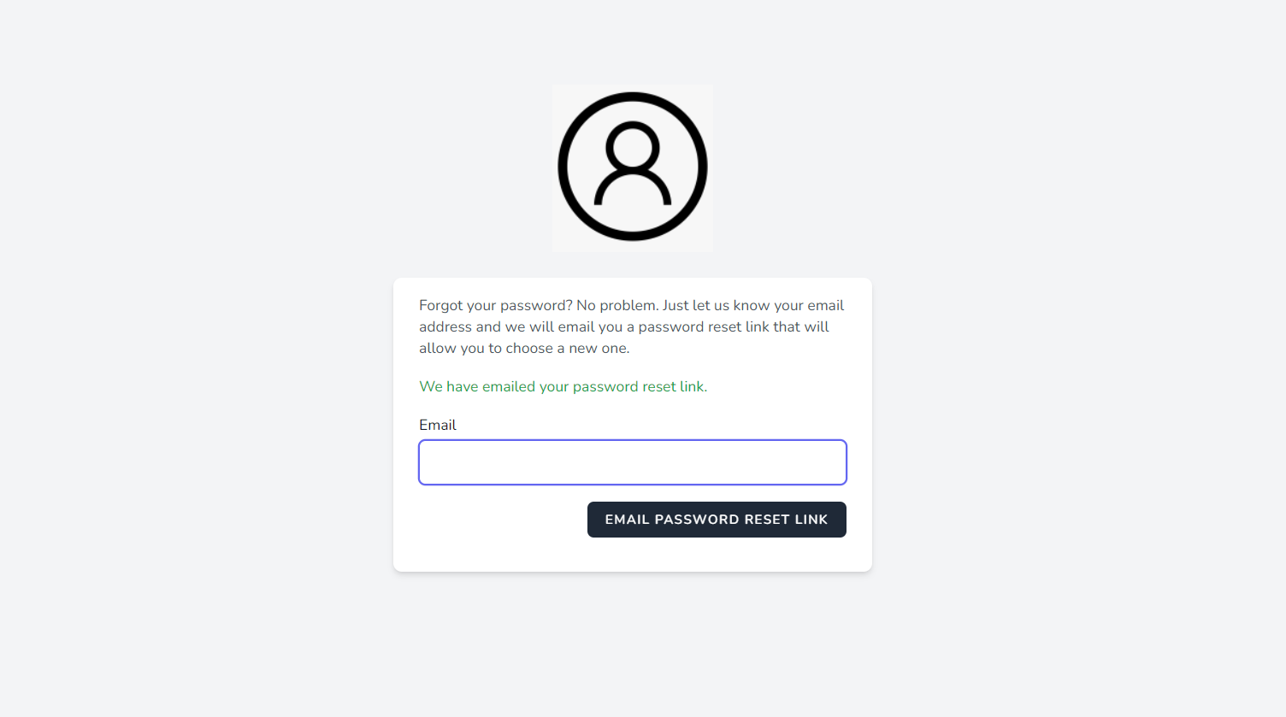

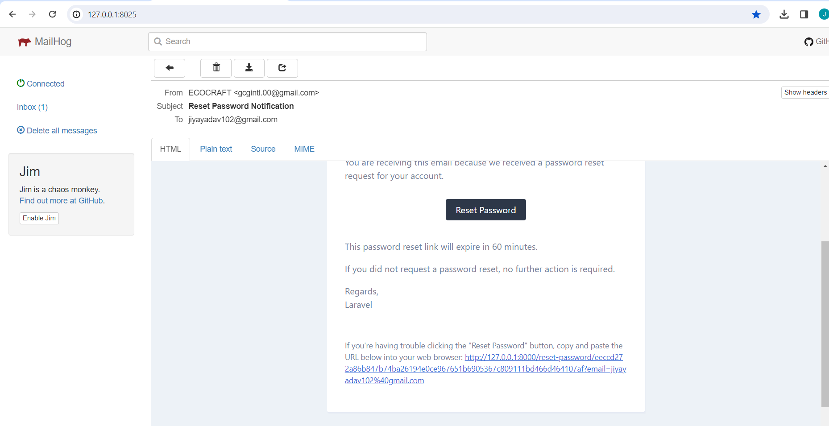

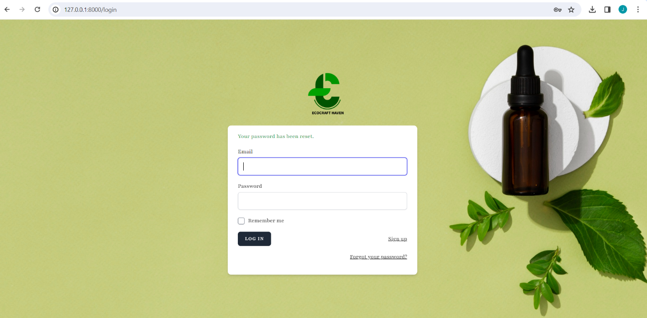

# Manage Products

## This page accessed by the Admins and Super Admins.

Here they can create product, edit product and delete product.

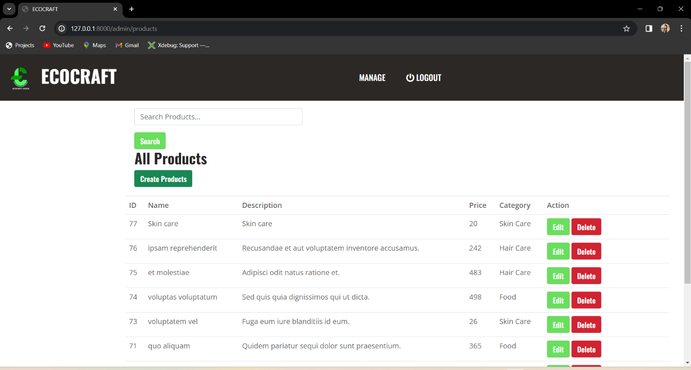

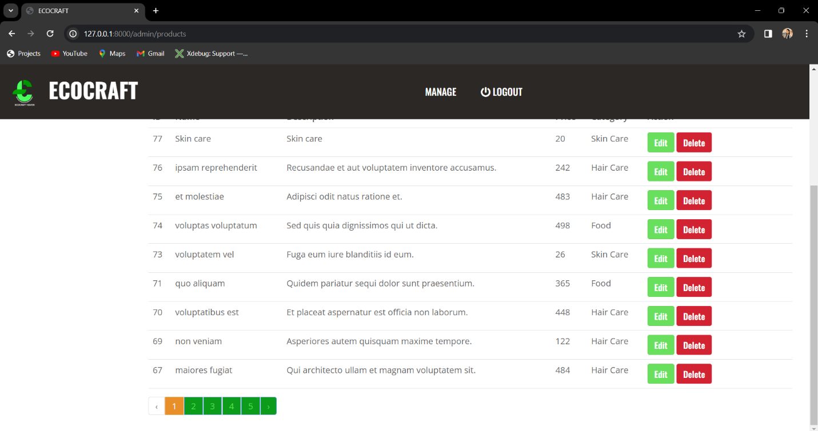

# Profile Edit page

Here user can update their profile.

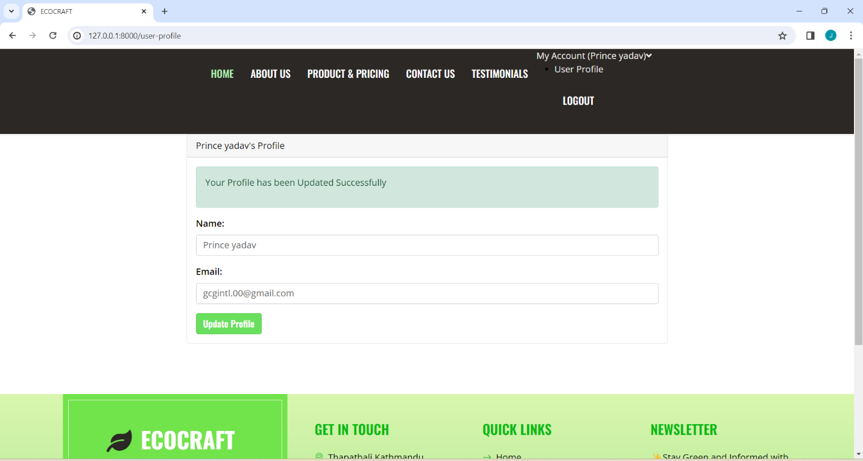

# Product edit page

## Admin and super admins can update the details of the products.

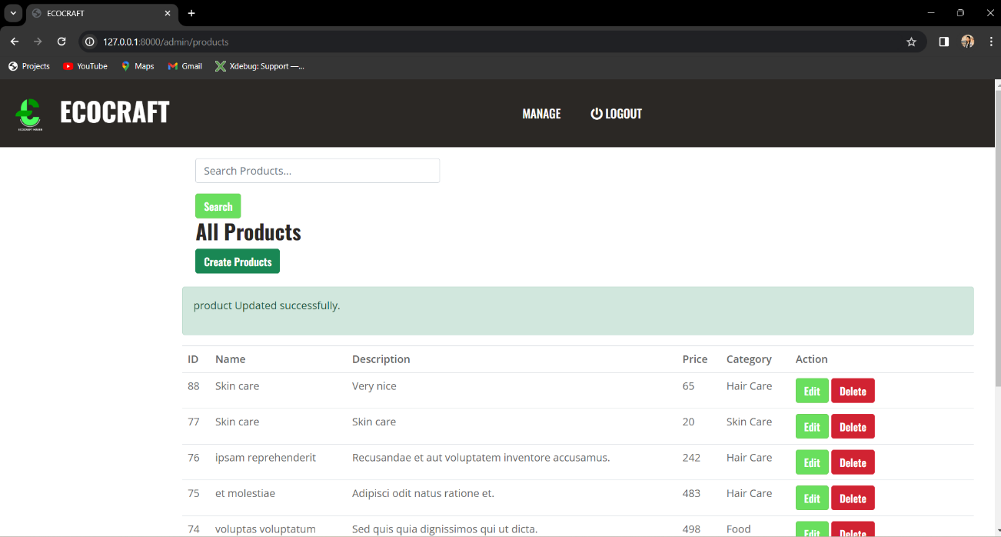

# Product deletes

## Admin and super admins can delete the details of the products.

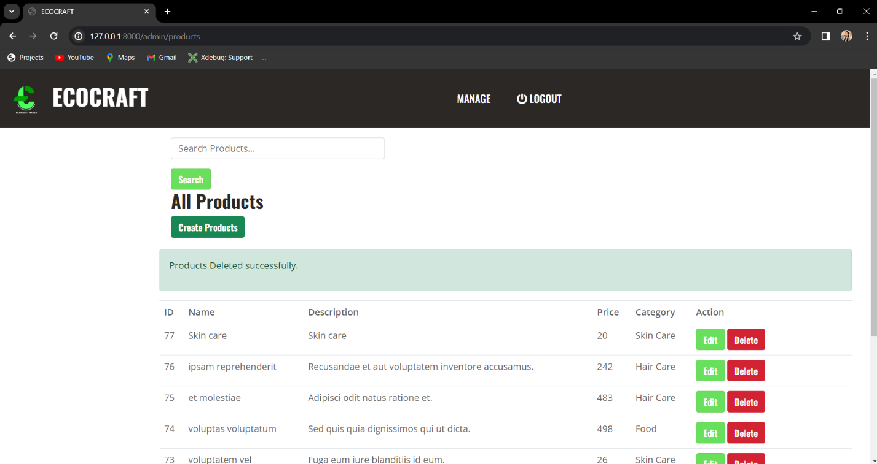

# Product creates

## Admin and super admins can create the products.

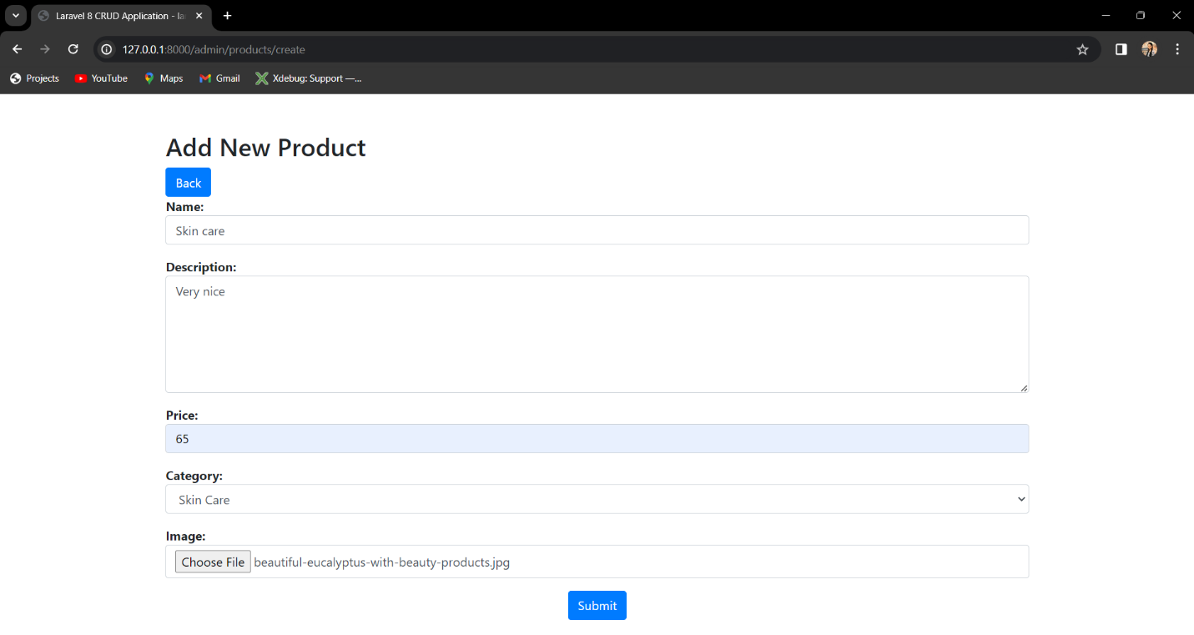

# Manage Users

## Only super admins can manage the user.

They can change the user role and can also delete the users.

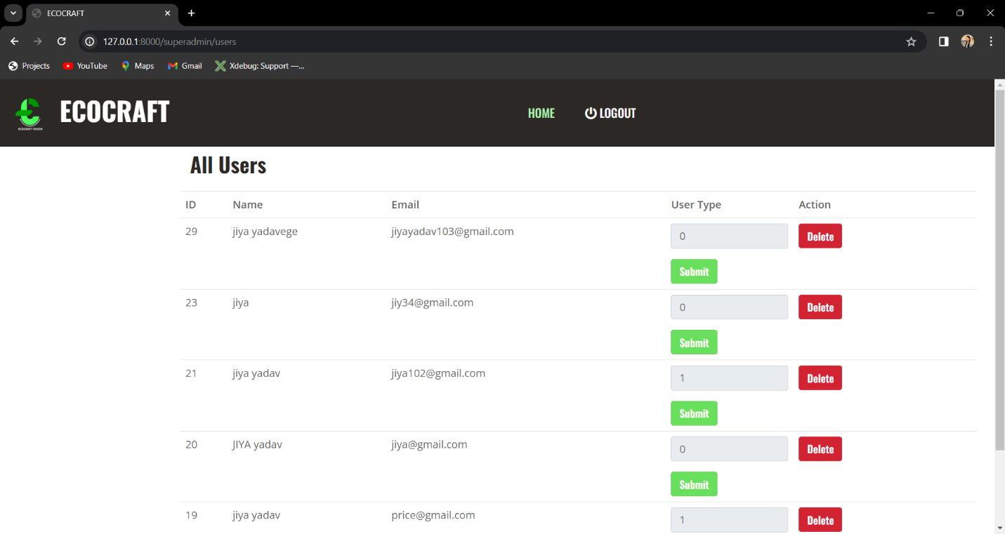

## User update

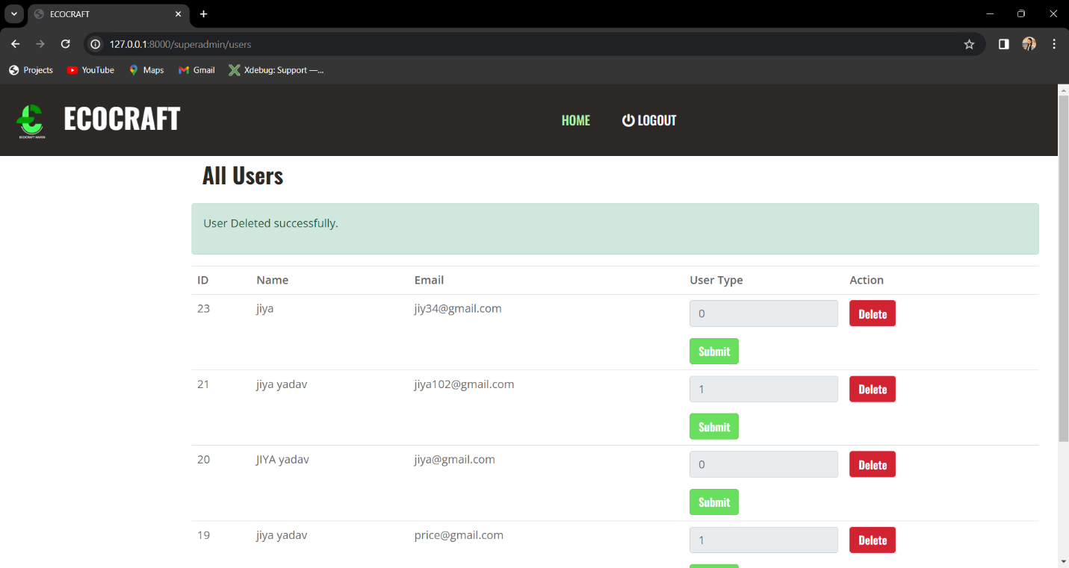

## User delete

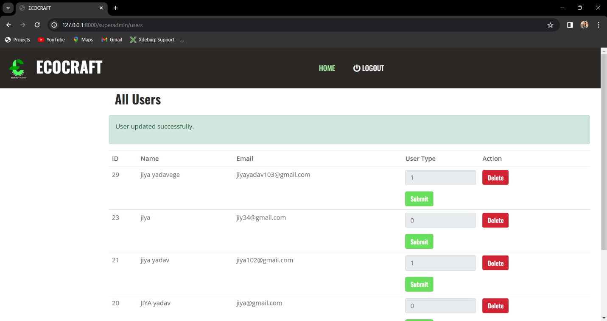

# Error page

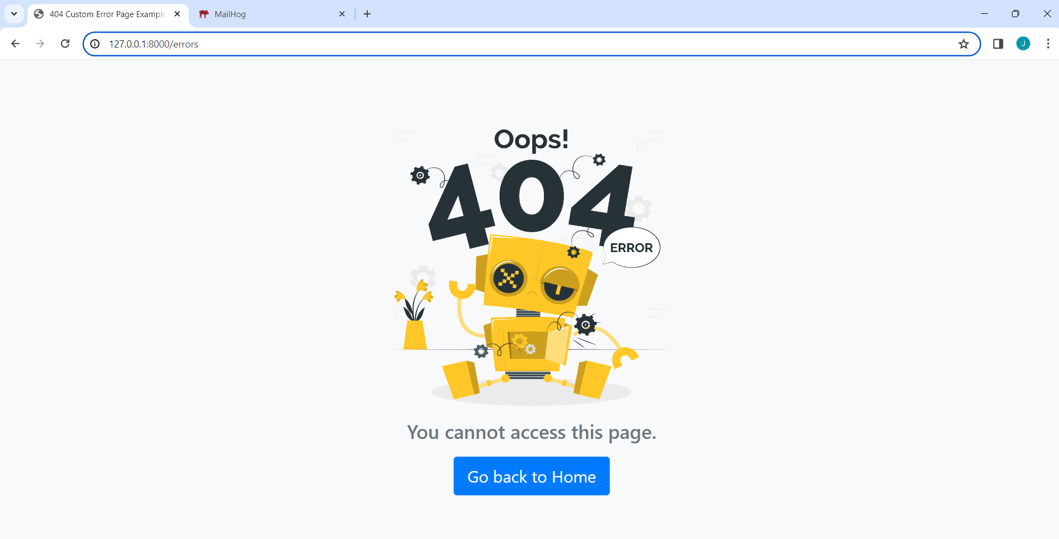

# Codes

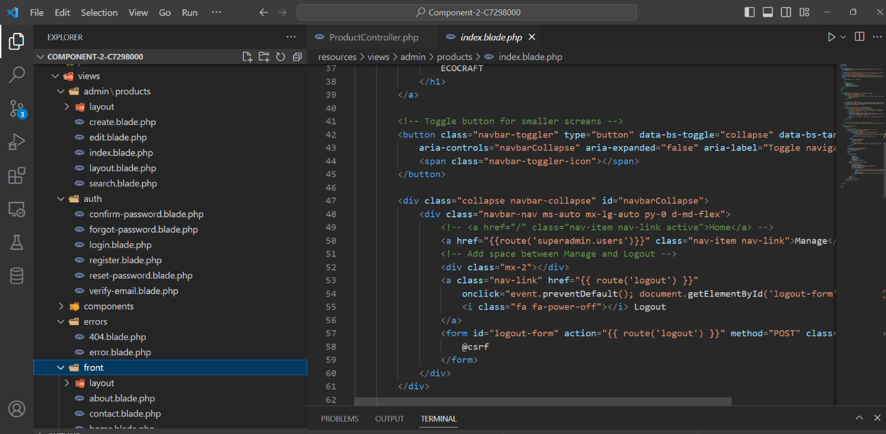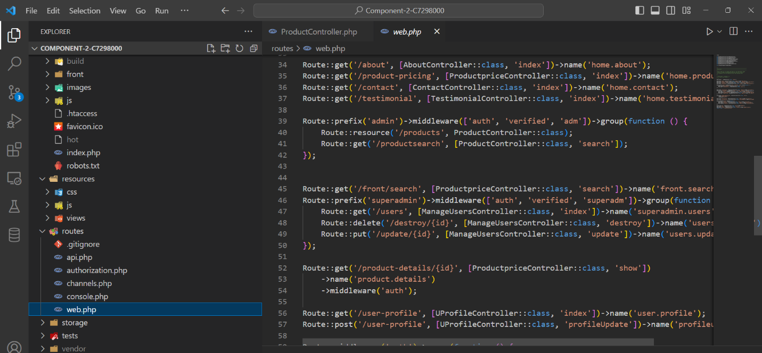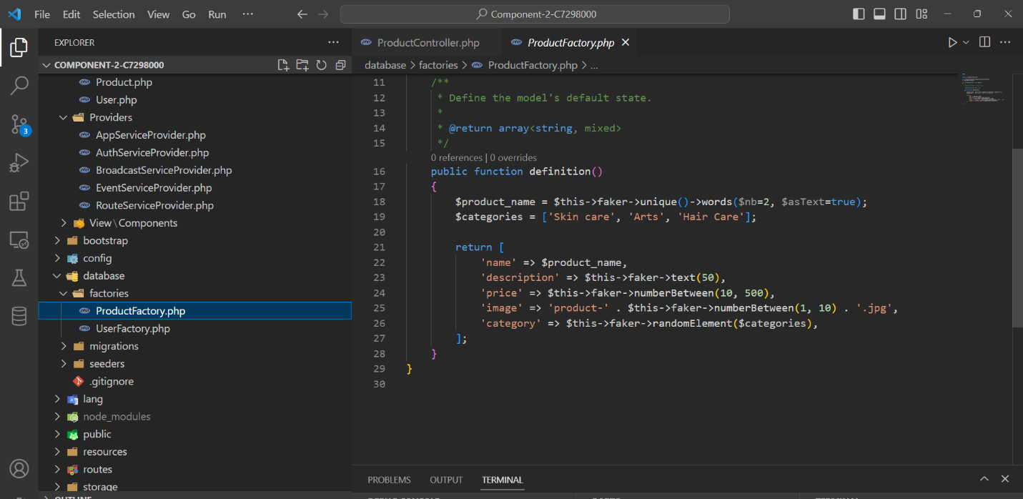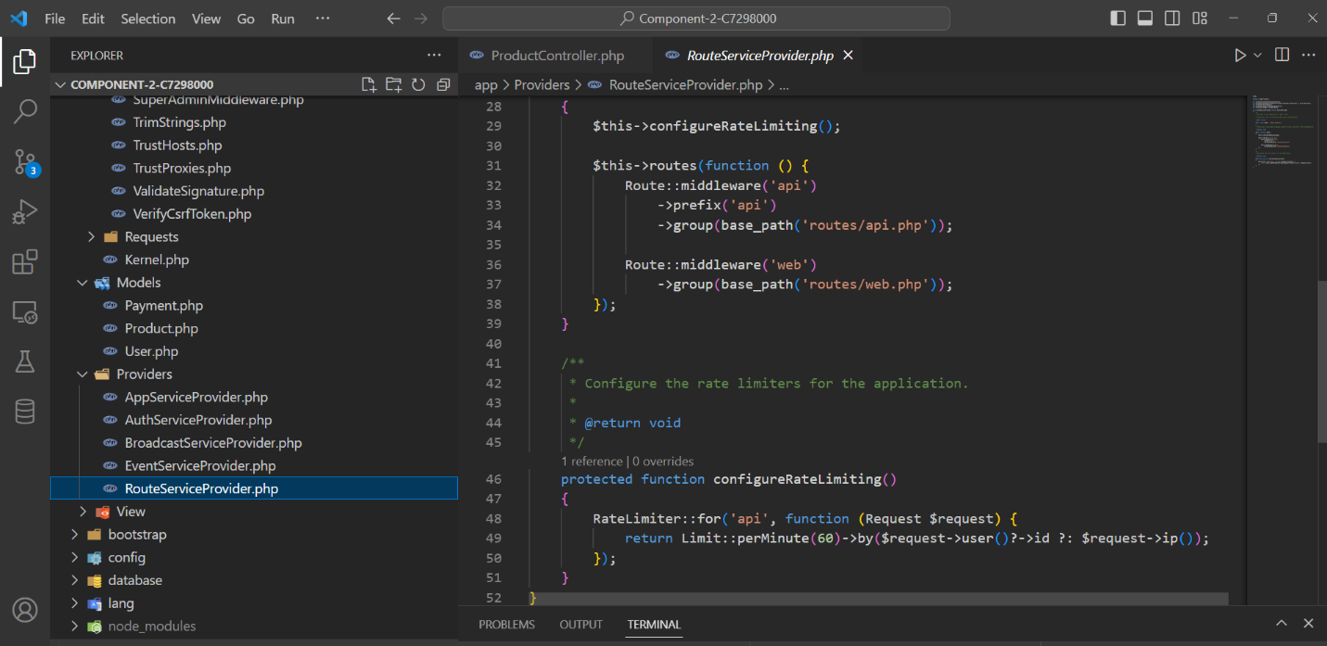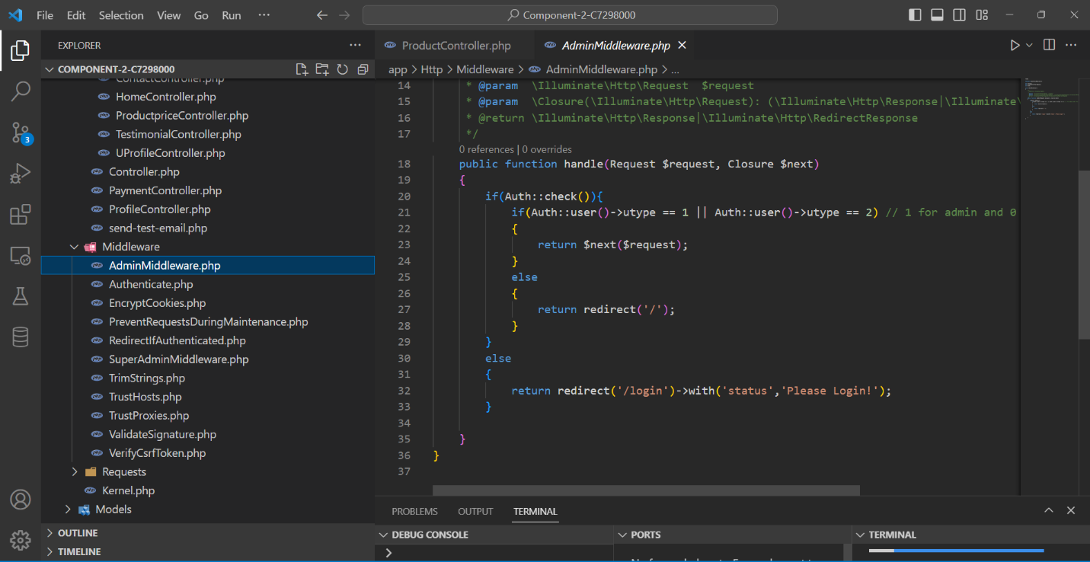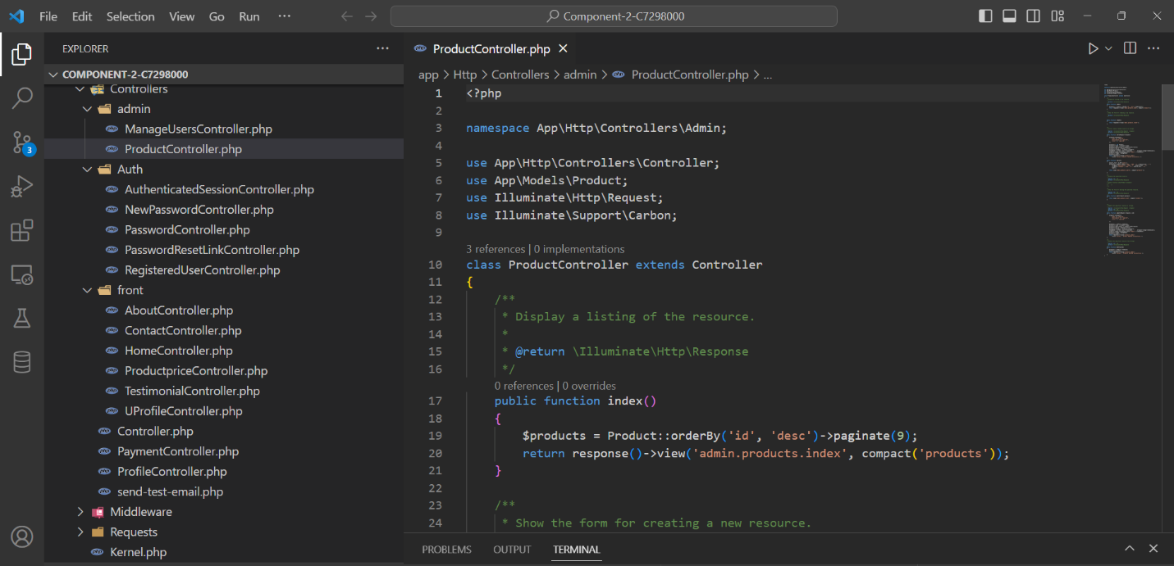

# Git hub:

## Local:

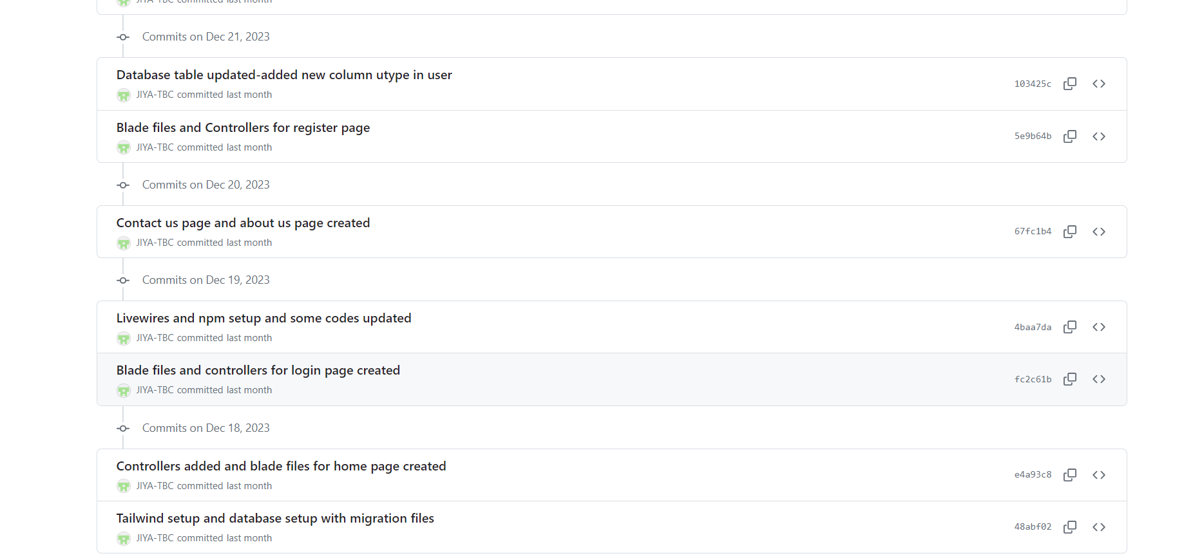

## Leeds Beckett:

